**Brief Site Map of recipe.com**

(by Brendan Boursiquot)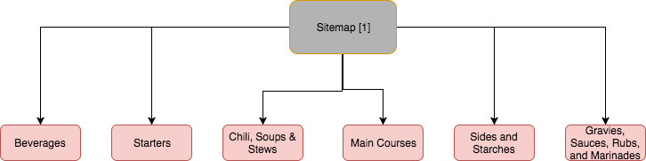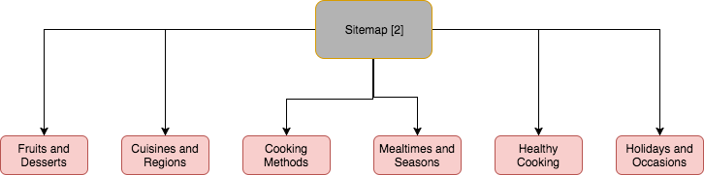

Home Page

Sitemap

About Us

Advertise

Twitter

Facebook

Tools